GP3 Part 1 – Team Squirtle
After completing both primary and secondary research, our team grasped a concept of what our prospective users are looking for in a solution to the sports data gathering & betting process. To actualize this concept, we first brainstormed 10 possible prototype ideas, then developed 2 low fidelity sketches, and finally a simplistic Figma mockup heavily inspired by the sketches, but with more of a focus on the general layout of things.
10+ Ideas we came up with initially:
1.) Betting App with Data Analytics(Sports One) [chosen for low fidelity and high fideltity]
Betting on Different spots based on gathered data and analytics
2.) Analytics Ai extension[chosen for low fidelity]
Give you informed analytics, on whatever you need whenever you go to a sports betting sight. Has querying as well
3.) Specific Analytics App
Only hardcore analytics with Ai integration to make querying easier, and be a one stop shop for analytics
4.) Odds comparison App
Tool that has an api compiling data from other sportsbooks
5.) Widget dashboard App
App that allows user to put together widgets of different sports betting related actions such as betting, news, and stats
6.) AI Sports Data Chatbot
Bot that uses historical data to provide betting insights
7.) Wearable friendly sports betting app
An application that is built to integrate with wearables like the Apple Watch, Galaxy Watch, or Pixel watch to make sports information quickly accessible.
8.) Advanced Sports Analytics tool
A backend tool that other companies or individuals can use to gather or generate useful data that relates to sports betting. It would have minimal front-end features but is designed to be a very robust back-end analytics service with good integration.
9.) Sports Analytics/Betting News Website
A website designed to provide concicse, easy to understand sports news, analysis, and betting recommendations using advanced analytics and a fast UI.
10.) A sports prediction engine
Some sort of tool or app or back-end service that uses up to date statistics to generate some sort of prediction for each game or player.
[Deeper description of the two low-fidelity prototypes you created, with images embedded for illustration (about 1/2 page each)
The First Low Fidelity prototype that we developed was a website SportsOne that is basically designed to be a one stops shop for all things sports betting and data analytics. 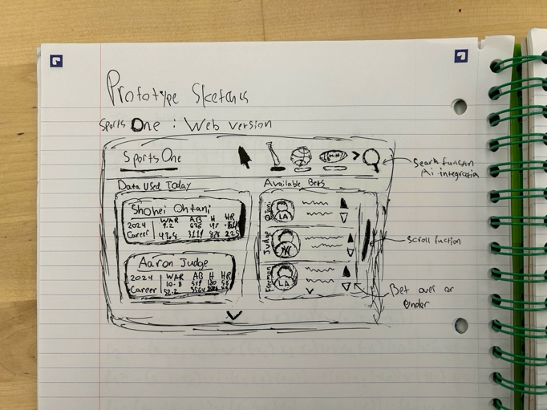 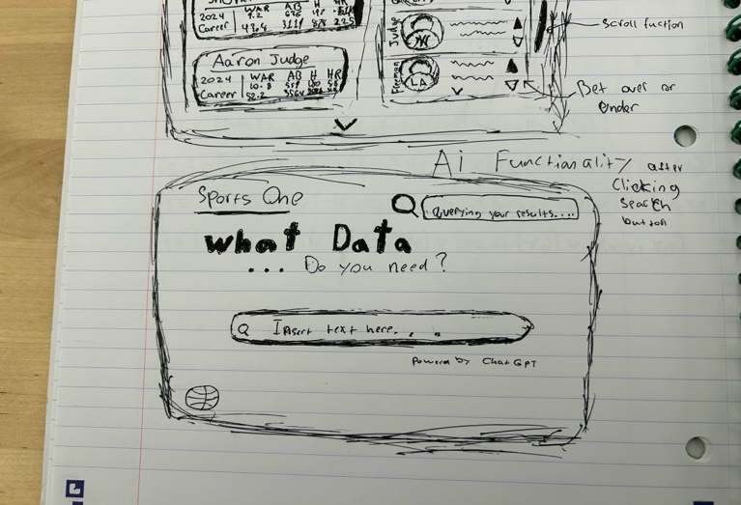
For this prototype we thought it was very important to include and specify on the aspects that were pain points in our original data gathering. One of the biggest issues that sports betters ran into was how difficulty it was to get to the data that you were looking for as fast as possible. On top of this issue, because, often times the data analytics sites and the actual sports betting websites are two different applications, the time for one to actually go about placing a bet increases exponentially. We decided the best course of action was to create an intuitive UI that made it easy to see the bets available, as well as the most common bets, but also the data on such bets all at one time. This was integral in creating an environment that would be suitable to the stake holding group that we interviewed. As you can see in the sketch, our landing page is split between the most common bets, along with the most common analytics. The goal is to use Ai to keep track of what is the most commonly used data, as well as what current events are even taking place at the time that sports betters may be looking to gather info on. It was also very important for our users to be able to easily switch between the types of sports they want to bet on and the types of data they can see. This is why we have the toggle at the top of the screen that will allow users to switch between their most commonly used sports for betting and analytics(this will be monitored with Ai, Caching, and Login credentials). This means when they first go to the app it will be a blank slate, in terms of our stored data on the user, and as such, the most commonly used, or the most relevant sports will be shown at the top of the screen. We will also be using Ai Integration in the search functionality to improve the effectiveness and speed of user querying. This will be done using chatgpt or another ai system to either query from credible sites, or sort through data that may be consistently uploaded and updated in our database so that we can give the user, clear, accurate and informed data.
Our second low fidelity prototype is an AI chrome extension tool for data analytics that will activate when you get to a site that is designed for sports betting. Sai(Sport Ai Extension) will basically pop out when it recognizes a specified site, and then provide you with data that is relevant to whatever bet you are looking at.
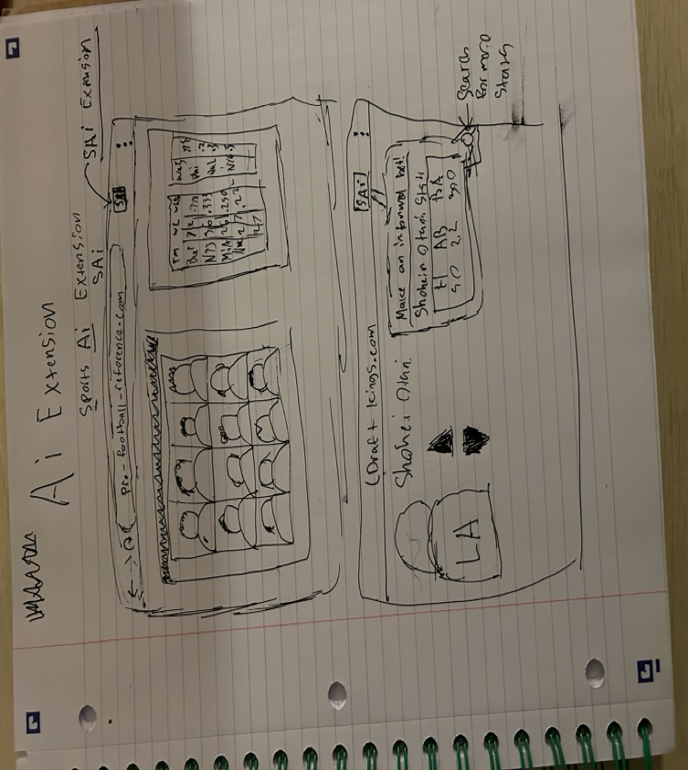
The goal here is not to necessarily create an entirely new app, but rather a helper that will assist the user in determining the right course of action when making a bet. The whole concept of this basically stems from the fact that most of the most commonly used sports betting applications already have user pools and people who rely on them every day. They have gotten used to their tendencies and features, so this will allow people not to have to learn an entirely new system, but rather have something that will allow what they are already using to flow much more seamlessly and create a better experience overall. This idea, though not a one stop shop by itself, creates one out of almost any site. We also are fairly aware that we don’t have every sports betting site in our system so there will be an application button where you can submit a request to the developers to allow this site that you use for sports betting to be integrated into our site.

One relative merit of the low fidelity prototype is that it has a appealing and art driven design, which different sport shapes as icons. This is in stark contrast with the purer “data overload” interface of sites like ProFootballReference. Another merit is that the low fidelity prototype also has a search bar, which can allow users to search for stats/players they want to learn more about. A drawback of the low fidelity prototype is that the design doesn’t include some of the core functionality needed by different betters. This includes things like integration with live news or advice from well-known betters. Another drawback is that some icons are rather large which may help with accessibility, but there are also large portions of unutilized space (such as in the “What Data Do you need?” section). A merit of the high-fidelity prototype is that it has a cleaner interface and can fit more information in a compact area. However, the interface can also be customized with the minimize feature which can hide away more advanced and unnecessary information that beginners may not use. A drawback as discussed in class was that the interface didn’t look as visually appealing and doesn’t have much character, one comment mentioning that “it looks like Facebook”.
Once we completed the low-fidelity sketches, we then worked on our higher-fidelity prototype. This involved converting these sketches to a digital format, taking the form of a series of Figma mockups. In terms of the design, we decided to stick with the same layout as the sketches, but also added colors to the headers. We believe this gives the app a little bit more personality. We also added some basic interactivity so that the user could simulate scrolling up and down the page to see different screens. We also added pictures of players to the betting section, as well as minimize buttons over each pane, and a panel on the right to open panes that are currently closed. We chose to add these details because one of the core value propositions of this app is the centralization of functionality, so being able to have multiple windowpanes open at the same time will allow users to take advantage of this and multitask.
Since our final product choice is a website, we should adhere to WCAG standards to create a product that is accessible to as many people as possible. This means that with every element in our site, and in every step of the revision process of our prototype, we should consider how they fit to those standards. For example, when choosing our color scheme we should think about using high-contrast colors so that people can see them better, or selecting larger font sizes so that the text is easy for everyone to read. Audio/visual aids would be helpful in many areas of our website, and easy keyboard functionality would be key for us to implement as well, for a few more examples. Not only will this help us provide easier access for more people, but it will also provide a smoother, better experience for all users.
Going forward, we want to look to refine our high-fidelity prototype with the feedback we received from our in-class critique. We received useful insights from classmates on potential improvements to our design and will look forward to implementing them in future versions of it. Our next steps include heuristic evaluation of our design from each group member which will help us evaluate each portion of our design to create a more well-rounded, refined version of what we have so far. Our goal with the SportsOne prototype is to create a service that will provide bettors with easier access to data that they want to see so they can make a more informed bet, and with these revisisions we hope to attain that goal.
Sketches (Low-fidelity prototype)
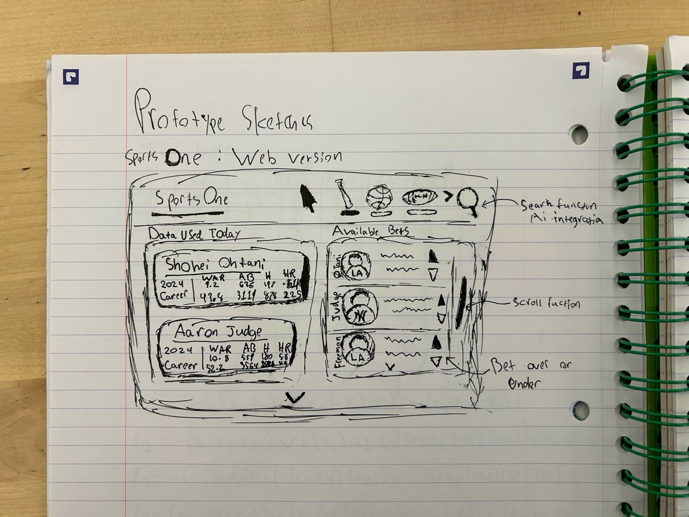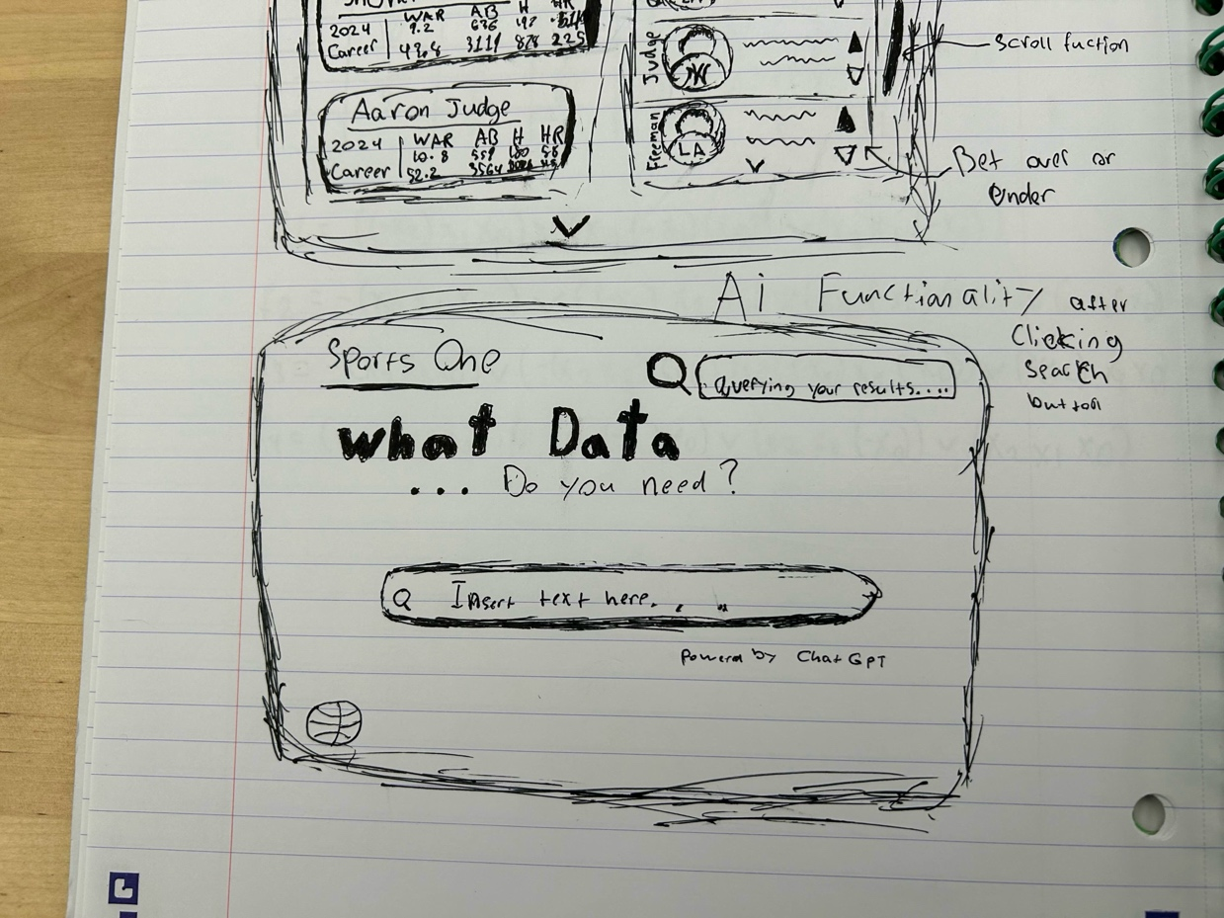
Figma Mockups (High-fidelity prototype)
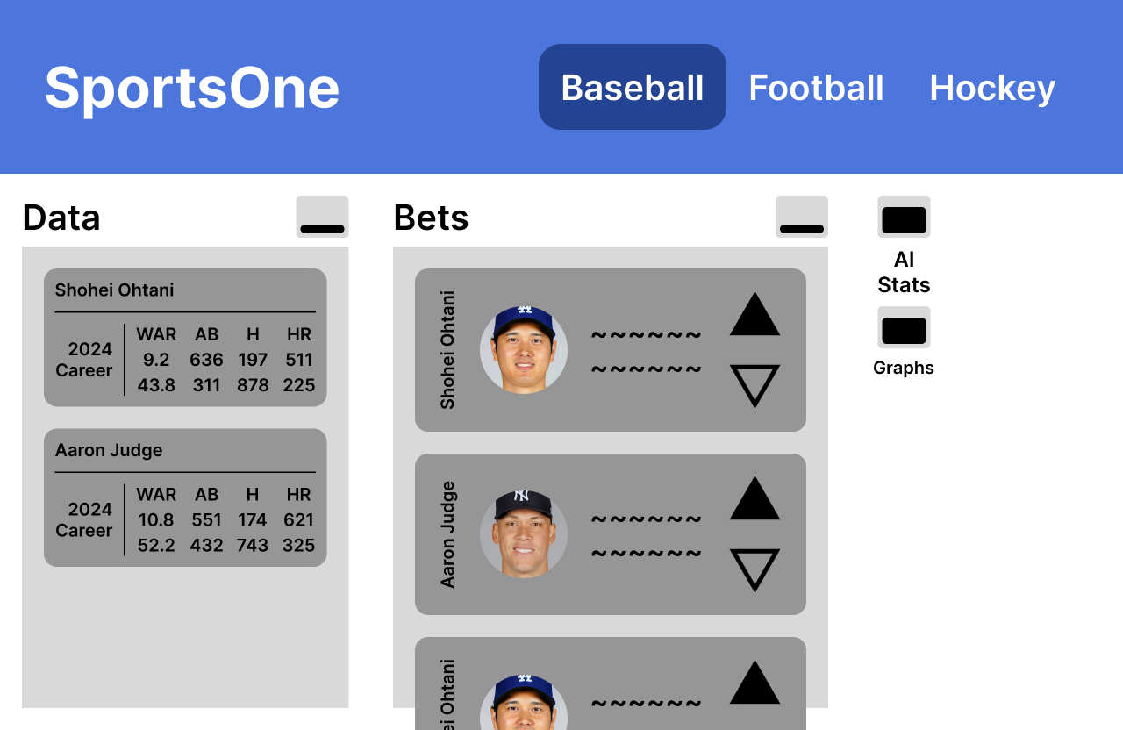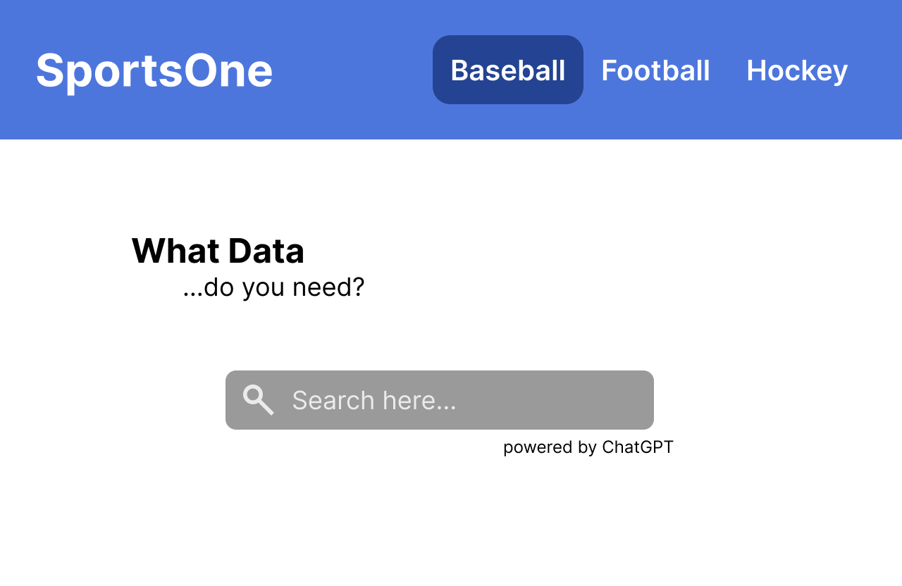
Roles & Contributions
John - I worked on the introduction, the high-fidelity prototype, as well as the paragraph discussing the high-fidelity prototype
Bill - I completed the "Brief discussion of the relative merits and drawbacks of the two designs" section
David – I worked on the description of the low fidelity prototypes as well as sketched them out buy hand.
Jake - I worked on the conclusion and the accessibility consideration sections.

